Logistic Regression

Gradient Descent & Code From Scratch
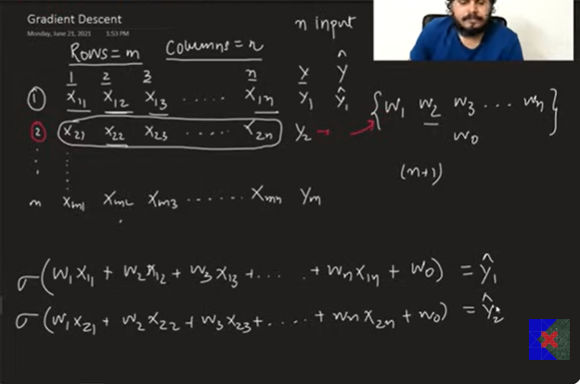
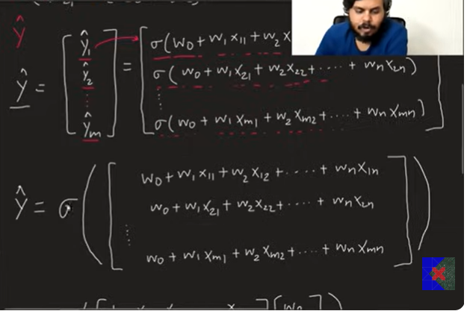

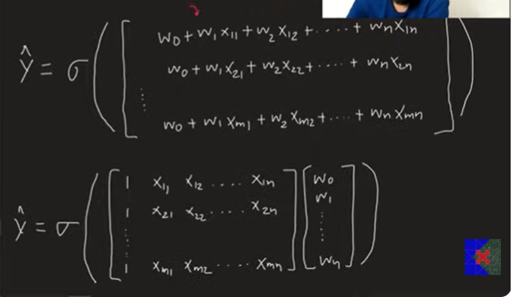
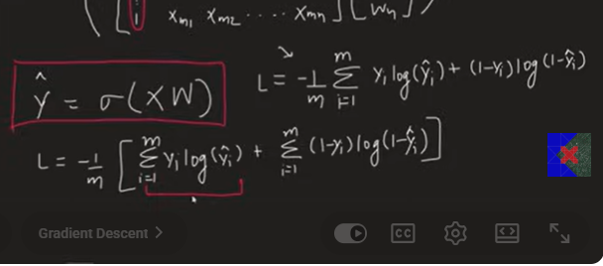
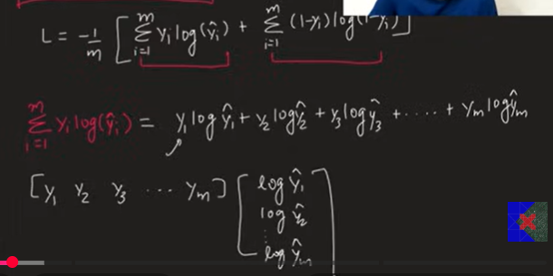
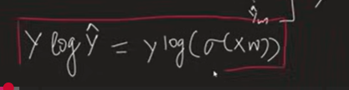
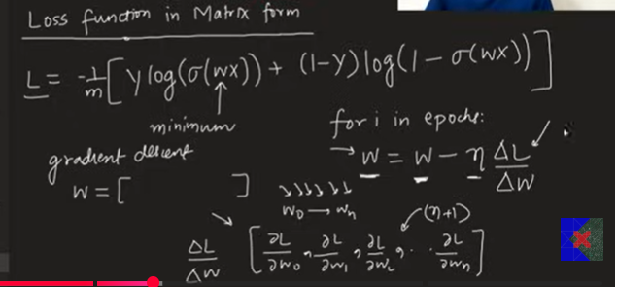
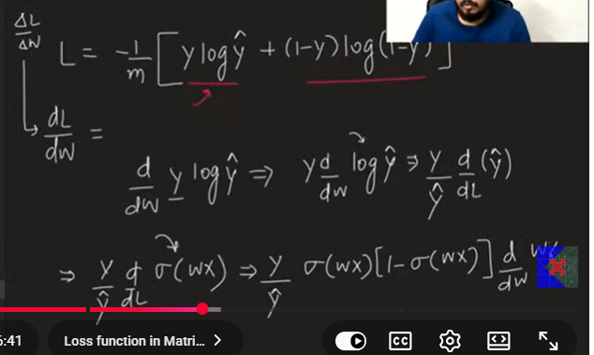
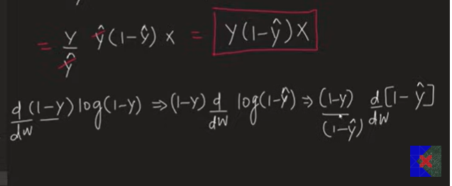
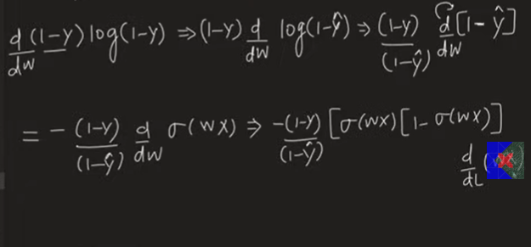
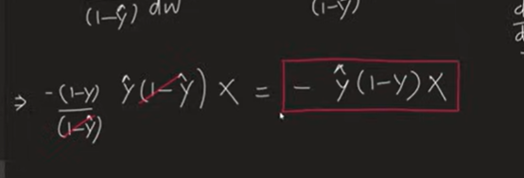
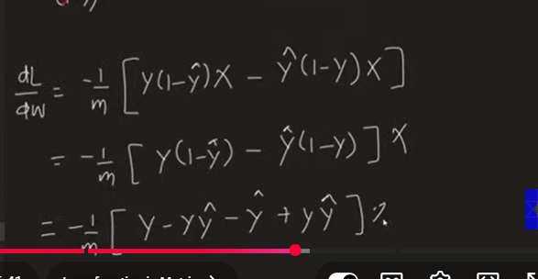
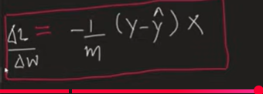
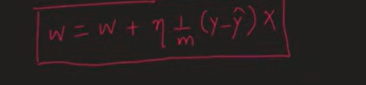

Why Gradient Descent?
In the previous lecture, we derived the Log Loss (Cost Function) for Logistic Regression.
The problem is:
- There is no closed-form solution for Logistic Regression.
- We cannot directly calculate the optimal weights.
- Therefore, we use Gradient Descent to minimize the cost function.

Dataset Representation
Suppose the dataset has:
- m = Number of training examples (rows)
- n = Number of input features (columns)
Input Matrix:
x1 x2 ... xn
Sample1 x11 x12 ... x1n
Sample2 x21 x22 ... x2n
...
Samplem xm1 xm2 ... xmn
Target Vector
Y =
[y1
y2
.
.
ym]

Parameters (Weights)
For n input features, Logistic Regression has:
w1, w2, w3, ..., wn
and one intercept
w0
Total parameters
n + 1

Prediction for One Sample
For the first training example,
Linear Equation
z = w0 + w1x11 + w2x12 + ... + wnx1n
Prediction
ŷ1 = σ(z)
where
σ(z) = 1 / (1 + e^-z)

For the second sample
z = w0 + w1x21 + w2x22 + ... + wnx2n

ŷ2 = σ(z)
Similarly,
ŷm = σ(z)

Matrix Representation
Instead of predicting one sample at a time,
we predict all samples together.
Prediction Vector
Ŷ =
[ŷ1
ŷ2
.
.
ŷm]

Linear Equation
Z = XW
Prediction
Ŷ = σ(XW)
where sigmoid is applied element-wise.

Final Prediction Formula
Ŷ = σ(XW)
This is one of the most important formulas in Logistic Regression.

Log Loss Function
For one sample
Loss = -( y log(ŷ) + (1-y)log(1-ŷ) )

For entire dataset
m
J(W) = -1/m Σ [yi log(ŷi) + (1-yi)log(1-ŷi)]
i=1

Matrix Form of Log Loss
The above equation can be written compactly as
J(W) = -(1/m)[Yᵀ log(Ŷ) + (1-Y)ᵀ log(1-Ŷ)]
where
Ŷ = σ(XW)

Why Gradient Descent?
Since
∂J/∂W = 0
cannot be solved analytically,
we minimize the loss using Gradient Descent.

Gradient Descent Algorithm

Step 1
Initialize weights
W = Random values
or
W = 0

Step 2
Repeat for many iterations
for i = 1 to iterations
Compute prediction
Ŷ = σ(XW)

Compute gradient
Gradient = (1/m) Xᵀ (Ŷ - Y)

Update weights
W = W - α Gradient
where
α = Learning Rate

Derivative of Log Loss
After differentiation,
the complicated derivative simplifies beautifully to
∂J/∂W = (1/m) Xᵀ (Ŷ - Y)
This is the most important result of the derivation.

Final Gradient Descent Update Rule
W = W - α (1/m) Xᵀ (Ŷ - Y)
or equivalently
W = W + α (1/m) Xᵀ (Y - Ŷ)
Both equations are mathematically identical.

Complete Logistic Regression Algorithm
Initialize W

Repeat

Z = XW

Ŷ = σ(Z)

Gradient = (1/m)Xᵀ(Ŷ-Y)

W = W - αGradient

Until convergence

Python Implementation Steps

Step 1
Add intercept column
X = np.insert(X,0,1,axis=1)

Step 2
Initialize weights
W = np.ones(X.shape[1])
or
W = np.zeros(X.shape[1])

Step 3
Choose learning rate
lr = 0.5

Step 4
Run Gradient Descent
for i in range(iterations):

Step 5
Compute prediction
y_hat = sigmoid(np.dot(X,W))

Step 6
Compute gradient
gradient = np.dot(X.T,(y_hat-y))/X.shape[0]

Step 7
Update weights
W = W - lr*gradient

Step 8
Return weights
intercept = W[0]

coefficients = W[1:]

Sigmoid Function in Python
def sigmoid(z):
return 1/(1+np.exp(-z))

Gradient Descent Function
def gradient_descent(X, y, lr=0.5, iterations=2500):

X = np.insert(X, 0, 1, axis=1)

W = np.ones(X.shape[1])

for i in range(iterations):

y_hat = sigmoid(np.dot(X, W))

gradient = np.dot(X.T, (y_hat - y)) / X.shape[0]

W = W - lr * gradient

intercept = W[0]

coefficients = W[1:]

return intercept, coefficients

Comparison with Scikit-learn
The implementation is compared with:
LogisticRegression(
penalty=None,
solver="sag"
)
The manually implemented Gradient Descent produces a decision boundary very close to Scikit-learn's Logistic Regression.
Increasing the number of iterations (e.g., 5000 instead of 2500) makes the manually learned boundary even closer.

Important Formulas (Exam Revision)

Sigmoid Function
σ(z) = 1/(1+e^-z)

Linear Equation
Z = XW

Prediction
Ŷ = σ(XW)

Log Loss
J(W) = -(1/m)[Yᵀlog(Ŷ) + (1-Y)ᵀlog(1-Ŷ)]

Gradient
∂J/∂W = (1/m)Xᵀ(Ŷ-Y)

Weight Update Rule
W = W - α(1/m)Xᵀ(Ŷ-Y)

Gradient Descent Algorithm
Initialize W

Repeat

Z = XW

Ŷ = σ(Z)

Gradient = (1/m)Xᵀ(Ŷ-Y)

W = W - αGradient

Until convergence

Key Interview Questions
Q1. Why can't Logistic Regression be solved directly?
- Because the Log Loss function has no closed-form solution.
Q2. Why do we use Gradient Descent?
- To iteratively minimize the Log Loss and find optimal weights.
Q3. What is the prediction equation?
Ŷ = σ(XW)
Q4. What is the gradient of Logistic Regression?
(1/m)Xᵀ(Ŷ-Y)
Q5. What is the final weight update rule?
W = W - α(1/m)Xᵀ(Ŷ-Y)
These formulas are the core of implementing Logistic Regression from scratch.

